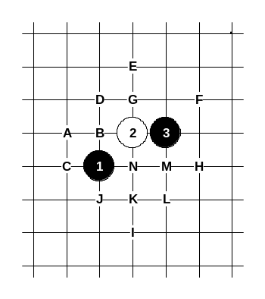
Opening Indirect 2
i2 峽月
Black is very strong in this opening as well as in any other “horse” type openings (the pattern of the 1st and 3rd stone make a “horse” step). The fans of both straight and positional attack must enjoy this opening a lot because the i2 opening offers the opportunities for both styles. In most cases (maybe 95%) black wins in this opening, therefore it is seldom used in serious competitions. This opening is usually set by players who like gambling style – they prepare traps in some variant and they hope that the black player is not prepared for this and falls into trap. Don’t worry, this opening has really few traps, so you can actually feel quite safe if you play it as black.
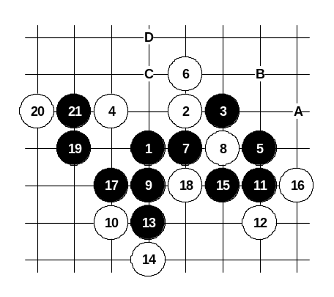

A

Diagram i2-1
This 4th move is very weak. Black wins without big difficulties. On this diagram the first choice of 5th move is shown.
If 16-18 then 17-A, 19-B, 21-16.
If 10-B then 11-14.
If 6-8 then 7-6, 8-16, 9-C (if 8-D then 9-16, 11-11).
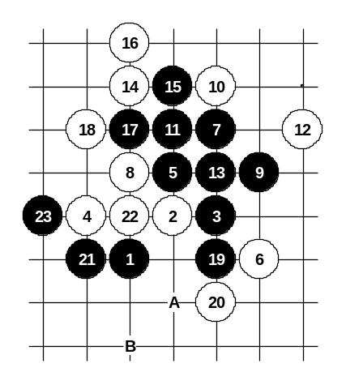

Diagram i2-2
Alternative 5th move. Black wins after series of correct development moves. The same variant can also come from i4 opening. There are no other serious 6th moves – black wins everywhere.
If 6-19 then 7-6. If 6-17 then 7-19.
Black can also choose several other 5th moves that lead to the familiar variants of other openings. For example, 5-A (i7 opening), 5-B (i10 opening), 5-8 (i3 opening).
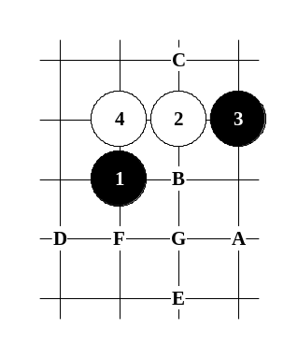
Black is very powerful in all those variants.

B

Diagram i2-3
Another 4th move. Black can choose between several powerful 5th moves: 5-A (i4 opening), 5-B (i6 opening), 5-C (i2 opening), 5-G (i7 opening).
Black can also choose other 5th moves that give black big advantage: 5-D (i11 opening), 5-E (i8 opening), 5-F (i9 opening).

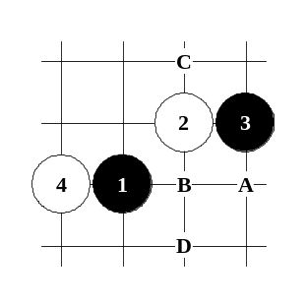

C

Diagram i2-4
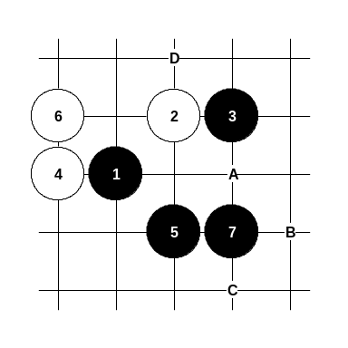
Another 4th move. This variant can also come from d12 opening. Black has four powerful 5th moves: A (d11 opening), B (d6 opening), C (d10 opening), D (next diagram).

Diagram i2-5
The 5th move has not appeared in previous renju books. Black has several powerful continuations here. The 7th move on this diagram leads to i7 opening with black sure win.
If 6-A then 7-B. If 6-C then 7-D.

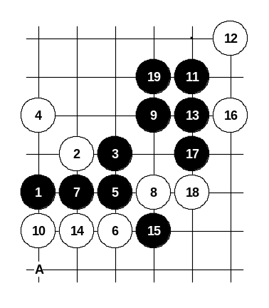

D

Diagram i2-6

Another 4th move. On the diagram the main 5th move is shown. Black wins here without any difficulties.
If 10-11 then 11-A.

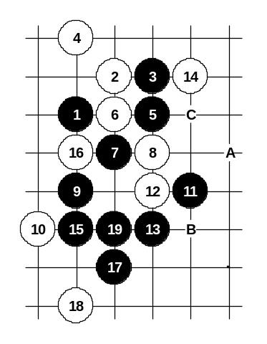

Diagram i2-7
This 6th move offers better resistance than 6-8, but after series of soft development moves 11-11 and 13-13 black wins anyway.
If 14-A then 15-B.
If 14-17 then 15-C.

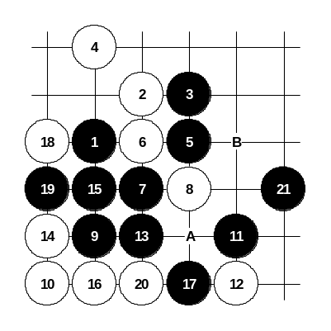

Diagram i2-8

Another 12th move. Black still wins.
If 8-A then 9-9, 10-10, 11-B.
If 8-9 then 9-B.

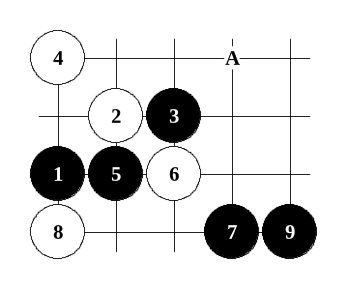

Diagram i2-9
This is the alternative 5th move.
By the 9th move black has got winning position. If 8-A then 9-8 and the variant will lead to d4 opening. If 6-8 or 6-A then black has straight win beginning from 7-6

E
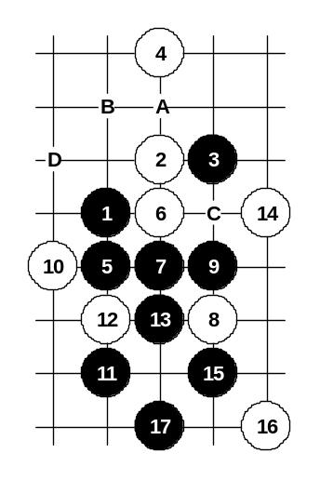
.
This 4th move has not been discussed in renju books before. The main 5th move 5-6 is very obvious, but finding an alternative 5th move is not easy. One simple solution is to play 5-B and lead the game to the variant of i2/i4 opening.

Diagram i2-10
Move 5-C has problems with continuation after 6-6.
Move 5-5 on current diagram seems to be the best alternative 5th move.
If 8-D then 9-9.
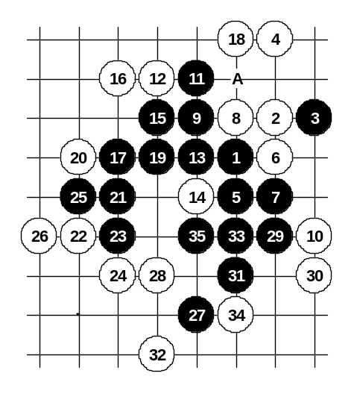

Diagram i2-11

Another 8th move. Black cannot win straight from move 9 and therefore the development move 11-11 is necessary. The straight winning attack begins from move 13.
If 22-A then 23-23.

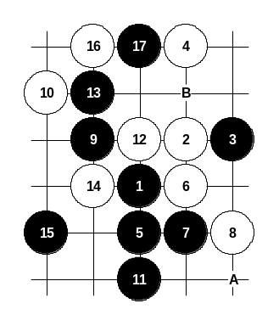

Diagram i2-12

Another 8th move.
At move 13 black gives up the tempo, but white cannot do much with that tempo. Beautiful 15-15 controls all white structures. Move 15-B is more peaceful but then black’s own attack might be complicated later. If 10-A then 11-13.

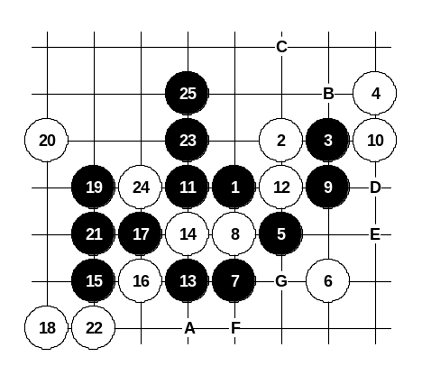

F

Diagram i2-13
Another 4th move.
White is very passive here and black can easily develop very powerful attack. If 12-D then 13-24, 15-E. If 10-A then black attack continues with playing to points 12, B, 10, C. If 8-F then 9-9, 10-10, 11-11, 12-D, 13-E, 14-24, 15-14, 16-23, 17-8, 19-G.
Alternative 5th move 5-12 leads to d4 opening.

G

Diagram i2-14
Another 4th move.
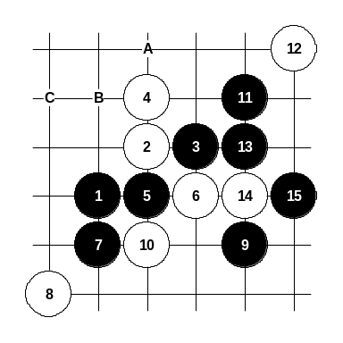
This is the main 5th move. By the 15th move black has prepared connections between left and right side’s source. The closeness of the right board edge does not influence black’s further attack. Alternative 5th move 5-A gives black very powerful position. The possible moves sequence would be 5-A, 6-B, 7-C and white is surrounded.
Move 5-B is not so good because in that case black’s attack goes towards smaller area and the space is not sufficient there.
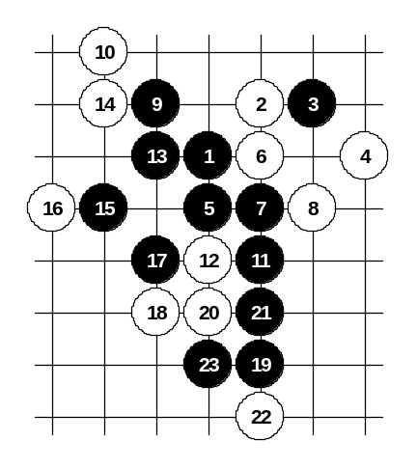

H

Diagram i2-15
Another 4th move.
Black wins here without problems. Similar position also comes from i8 or i4 opening with different distance to the board edges, however the board edge cannot influence the win here nor in i8 opening.
On the diagram the main 5th move is shown. Move 6-6 is the strongest but it still loses. Move 7-7 is useful in case of almost any 6th move.
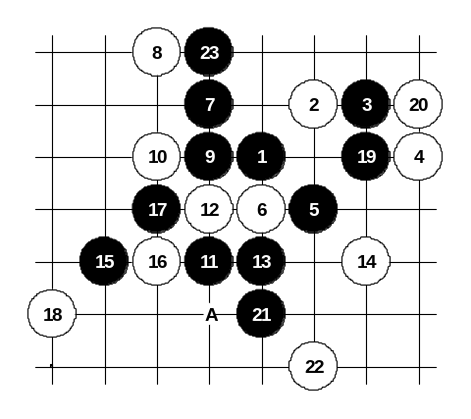

Diagram i2-16

This is the alternative 5th move. Black wins here.
In the old times move 7-14 was played but black play is more difficult there. Move 7-7 gives quite easy win.
If 12-A then 13-17.

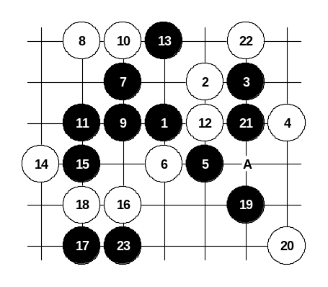

Diagram i2-17

Another 10th move.
After strong 15-15 white is unable to defend.
If 22-A then easy win in upper side.
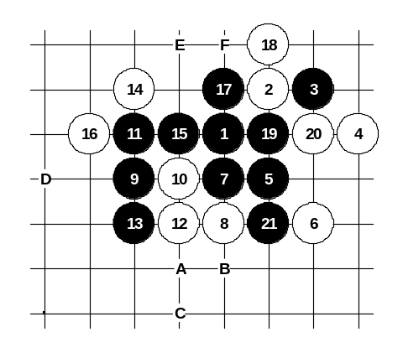

Another 6th move. Although black seems to be very powerful here, black unexpectedly faces lots of problems after 8-8. There have been lots of games in history where black had failed to win. However, this diagram shows black win. Beautiful moves 9-9 and 11-11 are the preparation moves. Move 12-12 is the best resistance. Finally, wonderful 19-19 and 21-21 give black win. If 22-E or 22-F then black has VCF.

Diagram i2-18
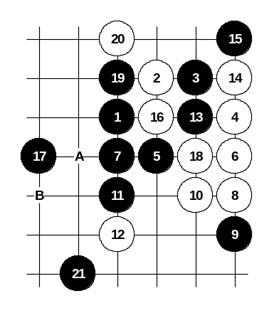
If 19-A then 20-B, 21-C, 22-D and black has problems.

Diagram i2-19

Another 6th move.
White plays very aggressively here. However, from move 11-11 black begins sure win attack.
If 18-A then 19-B.

I

Diagram i2-20
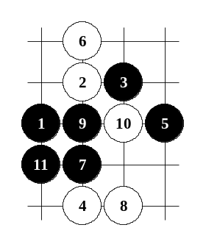
Another 4th move.
Although it is too far and too passive, black has to be careful in choosing 5th moves.
Move 5-5 is one of the good choices. The main 5th move is 5-9.

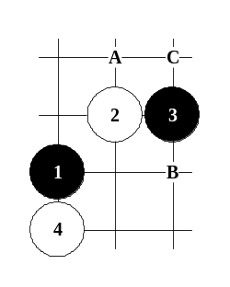
Another 4th move. This position can also come from d10 opening. The main 5th move is 5-A, black can develop there without any difficulties. Alternative 5th move is 5-B, that leads to i3 opening. Move 5-C is also possible (look at the diagram i1-5).

J

Diagram i2-21

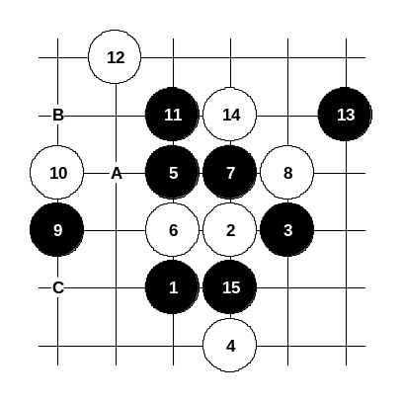

K

Diagram i2-22
Another 4th move.
Black can win here, although it is not very easy. Move 9-9 is the key move. If 10-A then 11-B. If 10-11 then 11-C.
The alternative winning 5th move is 5-7 (look at the diagram i2-2).
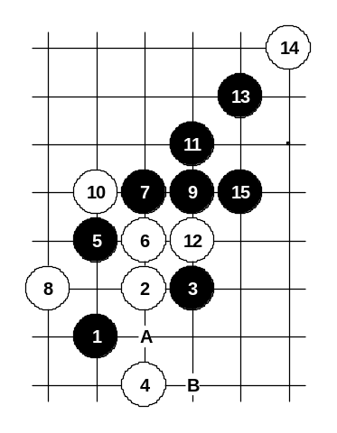

Diagram i2-23

Another 6th move. Move 9-9 is very powerful – white cannot defend after that.
If 10-11 then 11-A.
If 10-A, 12-11 then 13-B.
If 8-9 or 8-11 then 9-A.
If 8-A, 10-11 then 11-B.
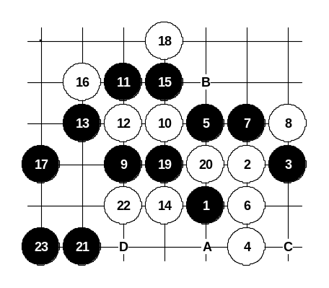

Another 6th move. It’s idea is to keep the forbidden point B open as long as possible in order to avoid black’s attack through that point. Move 9-9 is very strong. The attack on this diagram is just one of the examples.

Diagram i2-24
If 14-18 then 15-20, 16-A, 17-B, 19-15.
If 12-13 then 13-12. If 12-B then 13-13.
If 10-B then 11-13. If 10-20 then 11-B, 13-10.
If 10-C then 11-20, 13-D, 15-22. If 10-13 then 11-22.
If 8-10 then look at the diagram i1-14.

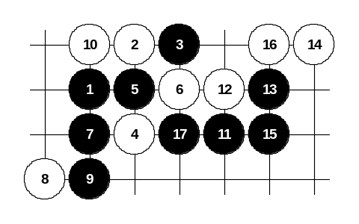
The third choice of the 5th move. Since the previous two 5th moves already give black win, this 5th move here is offered here just for reference. Black has a big advantage there, but making that advantage to become black win requires lots of skill and analyses. If white plays as shown on the diagram then black wins after beautiful move 17-17.

Diagram i2-25
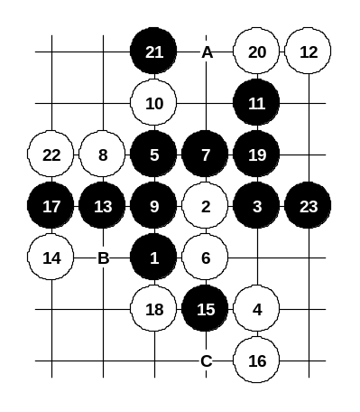

L

Diagram i2-26

Another 4th move. The main 5th move is 5-15 that leads to d5 opening. The alternative 5th move 5-5 is shown on this diagram. Move 8-8 is the strongest resistance, but black still wins. If 14-17 then 15-A. If 12-B then 13-20.
If 8-11 then 9-13. If 6-C then 7-7.

M

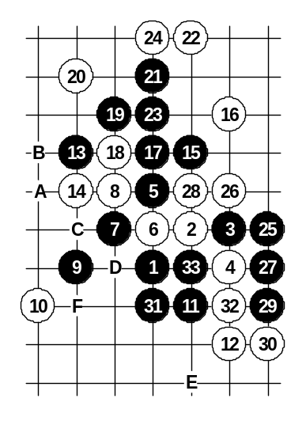
Another 4th move. This is stronger than any previously shown 4th move. On this diagram the main 5th move is shown. Although the variant is long and difficult, black wins surely here.

Diagram i2-27
If 20-28 then 21-A.
If 14-B then black has straight win starting with 15-C and 17-D.
If 12-14 then 13-31 and black has an easy win.
If 10-15 then 11-11, 12-14, 13-33, 14-31, 15-E (if 12-12 then 13-F).
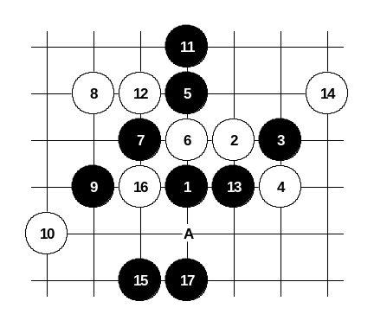

Diagram i2-28
Another 8th move. Black cannot win straight here and therefore a series of positional development moves are necessary. Finally, by the 17th move black wins.
If 16-A then 17-17.
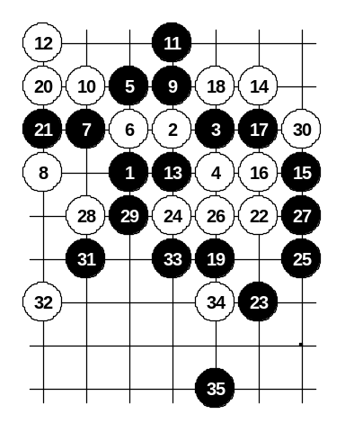

Diagram i2-29

Another 8th move. Black win here is extremely difficult. Black has to combine the forces of all sides and carefully develop the attacking structures.
Move 11-11 – Japanese idea.
Beautiful 15-15 connects the sides.
By the 25th move black wins.

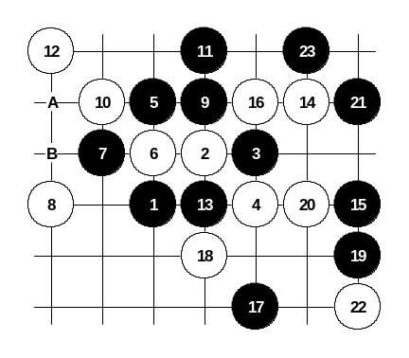

Diagram i2-30

Another 16th move. Black wins here even faster.
If 18-A then 19-B and white has spent its last active material and from now on black can develop easily without fear of white’s counter-attack.

Diagram i2-31
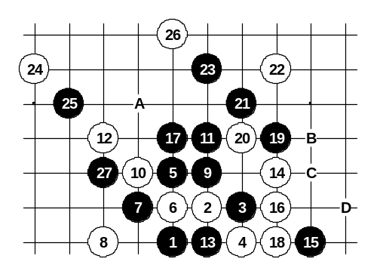
Another 16th move. Black drags the attacking material to upper side and wins. If 18-A then 19-19, 20-B, 21-21, 23-C, 24-D, 25-27. However, there are still some good defense moves after which the black attack is really difficult. Therefore, another 11th move can be used, too (11-17). See the next diagram. Black wins much easier there.

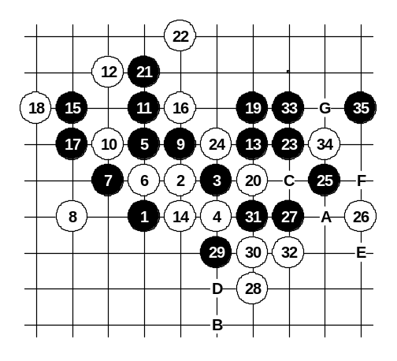

This 11th move has also occurred in old games. Black attack is long but without complicated side variants. That makes it easy to learn.

Diagram i2-32
If 20-29, 22-23 then 23-32, 25-A, 26-B, 27-C, 28-D, 30-E, 31-F, 33-G.

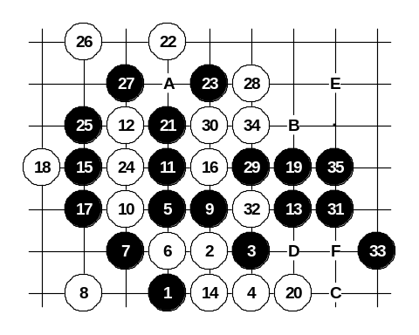

Diagram i2-33

Another 20th move.
If 28-A then 29-B, 30-C, 32-D, 33-E.
If 22-23 then 23-B, 24-D, 25-29, 26-C, 28-32, 30-F, and black has VCF.

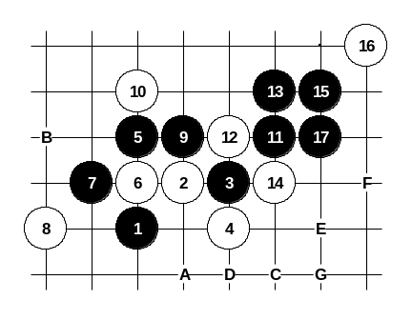

Diagram i2-34

Another 10th move. Here it is much easier to develop the attack. After 17-17 there is no defense.
It is also possible 17-A, 18-B, 19-C, 20-D, 21-E, 22-F, 23-G.

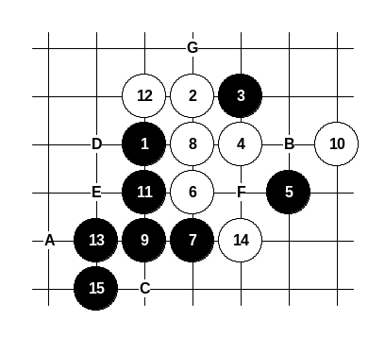

This is the alternative 5th move. Black can get very powerful position here, but it requires more skill of dynamic play. Other 6th moves than 6-6 are out of question – black is too strong (for example, if 6-14 then 7-G). However, even after 6-6 black can continue strong “net” development. On this diagram the first choice of 8th move is shown. Beautiful 15-15 gives black win. If 14-A then 15-B. If 12-C then black begins the attack with 13-D having many different ways to win.

Diagram i2-35
If 10-14 then 11-C, 12-11, 13-E (if 12-12 then black wins with 13-F).
If 10-C then 11-G.
Other alternative 5th moves are not so good for black. If 5-6 then 7-11. If 5-11 then 6-8 and despite the black’s initiative it is not easy to continue serious development.

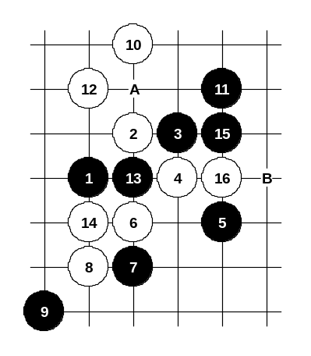

Diagram i2-36

Another 8th move – a three. It is the strongest white move. Black has two choices – wrong and right choice. The wrong 9th move is shown on this diagram. White sets up winning position with move 10-10.
Move 11-11 is the best resistance, but after beautiful 12-12 white changes the tactics to “waiting style”, and by the 16th move black “runs out of power” and white wins.
If 11-13 then 12-11.
If 11-A then 12-B.
If 11-15 then 12-A, 14-12.
If 11-16 then 12-15, 14-B.

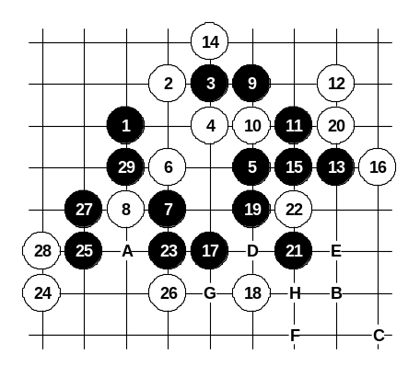

Diagram i2-37
This is the correct 9th move. The development until 13th move is very natural. On this diagram the weaker 14th move is shown. Black prepares the winning position with strong 17-17. If 24-A then 25-B, 26-C and black has beautiful VCF. If 24-D then 25-25.
If 20-26 then 21-21, 22-22, 23-E.
If 18-19 then 19-18, 20-F, 21-22, 22-21, 23-G, 25-H.
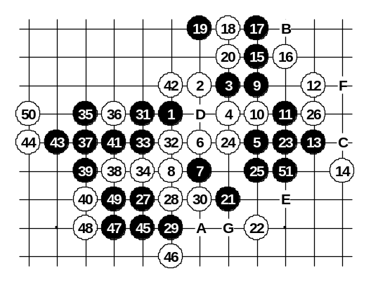

Diagram i2-38
This 14th move is much stronger. Move 15-15 is played in the same style as in i6 opening, however, the presence of stones 1, 8, 6, 7 makes the black attack here much more difficult compared with i6 opening. Move 16-16 is one of the strongest defense moves. Black attack is very long after that and includes several positional development moves such as 21-21, 27-27 and 29-29. Move 31-31 creates the final base for black attack and further moves are already black straight win.
If 28-29 then 29-34. If 26-A then 27-B. If 22-32 then 23-23, 24-C, 25-25, 26-26, 27-51. If 18-19 then 19-D, 20-32, 21-23, 22-C, 23-E, 24-51, 25-25, 26-24, 27-F (if 20-B then 21-23, 22-C, 23-E, 24-51, 25-25, 26-24, 27-21). If 18-B then black begins development with 19-21. If 16-D then 17-21, 18-22, 19-23, 20-19, 22-C, 23-51 (if 18-23 then 19-G). If 16-19 then 17-D, 18-32, 19-23, 20-C, 21-E, 22-51, 23-25, 24-24, 25-F, 26-21 and black has VCF. If 16-20 then 17-21, 18-22, 19-23, 20-C, 21-H, 22-16, 23-D. Conclusion about this 4th move: Black has two winning 5th moves, but the win is extremely difficult in both cases.
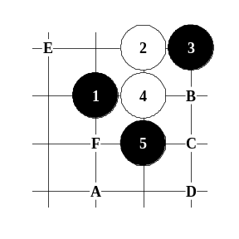

N

Diagram i2-39
Another 4th move. This is the strongest white move in this opening. Black can choose between several 5th moves. Move 5-5 is the strongest move – black wins everywhere. Some variants are difficult though and without having knowledge about it a player can easily fail the attack in the real game. On the following diagrams the moves 6-A, 6-B, 6-C, 6-D and 6-E are discussed.
If 6-F then look at d4 opening.
The strongest alternative 5th move is 5-C, black practically wins there, too.

